Proposal title
6 pages for FULL proposal

Aims and hypothesis:

A description of the research questions being tackled.
A few paragraphs should describe prior art.

Here, some of the questions and goals of this project should be listed as a bullet list.
- Aim/hypothesis 1
- Aim/hypothesis 2
- Aim/hypothesis 3

Experimental design and methodology:

Here you should provide a detailed description of the experiment design that tackles the aim and questions described above. Describe novel components that your experiment requires and the associated trade-offs.

You can use the information provided below to help convey your behavioral plan. Feel free to delete / adjust tables based on your experimental needs.

Head Fixation and stimulus training plan:
- Week 1 Handling:
Mice are typically handled for one week with a gradual increase of head fixation. No stimuli are presented during this period. We don’t anticipate any change to this protocol but this is listed here for completeness.

- Subsequent training if passively viewing:
DAY | SESSION DURATION | DESCRIPTION/CONDITIONS
6 | 10 min | Habituation day to Stim 1, 2, 3
7 | 20 min | Habituation day to Stim 1, 2, 3
8 | 30 min | Habituation day to Stim 1, 2, 3
9 | 40 min | Habituation day to Stim 1, 2, 3
10 | 50 min | Habituation day to Stim 1, 2, 3

- Subsequent training if activity trained:
Normal animal training occurs during 4 stages, each adding a level of complexity to the previous stage. Training can be aborted after any phase for subsequent neuronal recordings.
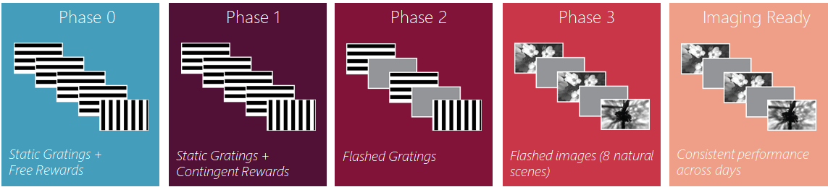
Stage 0:
The purpose of stage 0 is to present the lick spout and water rewards for the first time. Mice are given a single 15-minute session with a static grating that randomly changes orientation (from 0 to 90 degrees), and water rewards are given on every change; thus, rewards are not contingent on licking.
Stage 1:
The purpose of stage 1 is to learn task rules using an easy discrimination between two static gratings that differ in orientation by 90 degrees. At the start of each session, animals receive warm-up trials (lick-non-contingent rewards) that teaches licking behavior. After the warm-up trials, animals are required to lick in response to a change stimulus in order to get rewards. Performance must be above a threshold (peak d’ > 2 in a 100 trial rolling window) for 2 of 3 consecutive days to exit stage 1.
Stage 2:
In stage 2 a 500ms grey period is introduced between 250 ms stimulus presentations. A flashing stimulus makes the perception of change more difficult because it requires a visual short-term memory of the previous stimulus. Graduation to stage 3 happens after performance in 2 of 3 consecutive days (potentially including days in stage 1) is above a threshold (peak d’ > 2 in a 100 trial rolling window).
Stage 3:
In stage 3, the visual stimuli change from gratings to natural images, and stimulus flashing is maintained. Graduation to stage 4, where reward volume is decreased, occurs automatically after 3 sessions.
Stage 4:
The only difference between stage 3 and stage 4 is that the reward volume decreases, which typically increases the number of trials a mouse will perform before losing motivation.

Stimuli/task design:
Here you should provide a detailed description of all stimulus code. This description should be sufficient so that the stimulus could be implemented by the Allen Institute OpenScope team. All relevant parameters should be described and properly set. There could be multiple stimuli blocks involved, distributed across multiple sessions. If that is the case, please give a specific name for each block and describe it below.

- Stim 1: Description of the stimulus 1 and all associated parameters. Provide dropbox links to binary assets (images/movies) when relevant.
- Stim 2: Description of the stimulus 2 and all associated parameters. Provide dropbox links to binary assets (images/movies) when relevant.
- Stim 3: Description of the stimulus 3 and all associated parameters. Provide dropbox links to binary assets (images/movies) when relevant.
Data Generation Plan:
This should detail the neuronal recording sessions and provide sufficient information to set the entirety of the dataset. This table below is for 2P imaging but can be adapated for Neuropixels recordings.
 | Cre-line | Visual Area / Depth | Number of mice
Stim 1 | Slc17a7-Cre; Camk2a-tTA; Ai93(TITL-GCaMP6f) | VISp / Layer I + 2/3+ 4 + 5 | 10
 |  | VISl / Layer I + 2/3+ 4 + 5
Stim 2 | Slc17a7-Cre; Camk2a-tTA; Ai93(TITL-GCaMP6f) | VISp / Layer I + 2/3+ 4 + 5 | 10
 |  | VISl / Layer I + 2/3+ 4 + 5
Stim 3 | Slc17a7-Cre; Camk2a-tTA; Ai93(TITL-GCaMP6f) | VISp/ Layer I + 2/3+ 4 + 5 | 10
 |  | VISl/ Layer I + 2/3+ 4 + 5

Quality control consideration:
Here should be listed specific aspects of the datasets that will require more attention to ensure the best data quality. For example, whether a specific order of stimuli session is important or if a given session is more important than others. Keep in mind, the operational team could repeat sessions that failed for any reason.

Analysis plan:
How each hypothesis/aim listed in Aims and hypothesis will be tested with the generated dataset.
- Aim/hypothesis 1
A brief high level description of the analysis performed on the data to address this aim.
- Aim/hypothesis 2
A brief high level description of the analysis performed on the data to address this aim.
- Aim/hypothesis 3
A brief high level description of the analysis performed on the data to address this aim.

Consider including any pre-analysis performed on already available public datasets here.

References (no maximum):

